

This report is written so that it can be ‘Read Aloud’ by using word Microsoft
Enter and View Report
Highgate Lodge Care Home
Announced Visit -7th February 2024
Healthwatch Walsall – managed by Engaging Communities Solutions

What is Enter and View
Part of Healthwatch Walsall remit is to carry out Enter and View visits. Healthwatch Walsall Authorised Representatives carry out these visits to health and social care premises to find out how they are being run and make recommendations where there are areas for improvement.

The Health and Social Care Act allows Authorised Representatives to observe service delivery and talk to service users, their families, and carers on premises such as hospitals, residential homes, GP practices, dental surgeries, optometrists, and pharmacies.

Enter and View visits can happen if people tell us there is a problem with a service but, equally, they can occur when services have a good reputation so that we can learn about and share examples of what they do well from the perspective of people who experience the service first-hand.

Healthwatch Walsall Enter and View visits are not intended to specifically identify safeguarding issues. However, if safeguarding concerns arise during a visit, they are reported in accordance with Healthwatch Walsall Safeguarding Policy, the service manager will be informed, and the visit will end. The Local Authority Safeguarding Team will also be informed.

Contents:
Page
What is Enter and View 2
Provider details 3 - 4
Acknowledgments 4
Disclaimer 4
Authorised Representatives 4
Who we share the report with 4
Healthwatch Walsall details 5
Healthwatch principles 5
Purpose of the visit 5 -6
What we did 6
Environment findings 6 - 7
Resident interviews 7 - 9
Relative Interviews 9
Staff interview 10
Manager interview 10 - 11
Findings 11 - 12
Recommendations 12
Provider feedback 12

Provider details
Name and Address of Service: Highgate Lodge Care Home
66 Highgate Road,
Walsall,
WS1 3JE
Tel: (01922) 646168

Specialisms /services:
- Accommodation for persons who require personal care
- Caring for adults over 65 yrs
- Caring for adults under 65 yrs
- Dementia
- Physical disabilities

Home to resident capacity is 24 residential care spaces. There are currently 19 residents at the home. There is one couple’s room, and the remaining are single resident bedrooms.

Staffing
- Day – 1 Senior Carer, 2 Carers, 1 Cook, 1 Laundry, 1 Morning Domestic & 1 part time
- Night – 1 Senior Carer, 1 Carer, 1 on call

Vacancies: 1 x Activities Co-Ordinator & 1 x Deputy Manager

We were told that the home does not use agency staff, they also have two bank staff. Any shifts or holidays are covered by existing staff.

Current CQC report status: GOOD across all five categories
Latest inspection: 28 February 2023
Report published: 15 April 2023
Link to CQC report: https://www.cqc.org.uk/location/1-12801966335?referer=widget3

Acknowledgments
Healthwatch Walsall would like to thank the Home Manager, owners, and care staff and all the residents and relatives for their co-operation during our visit.

Disclaimer
Please note that this report is related to observations and findings made during our visit made on 7th February 2024. The report does not claim to represent the views of all service users and staff, only those who contributed during the visit.

Authorised Representatives
Tom Collins – Engagement & Information Lead, Healthwatch Walsall
Peter Allen – Community Outreach Lead, Healthwatch Walsall

Who we share the report with
This report and its findings will be shared with the provider, Local Authority Quality in Care Team (depending on the visit), Black Country Integrated Care Board (BICB), Care Quality
Commission (CQC) and Healthwatch England. The report will also be published on the Healthwatch Walsall website. Link: https://tinyurl.com/3tuhmdrx

Healthwatch Walsall Contact Details
Address: Blakenall Village Centre, 79 Thames Road, Blakenall, Walsall WS3 1LZ
Website: www.healthwatchwalsall.co.uk
Freephone: 0800 470 1660
Social media: Facebook - https://www.facebook.com/HealthwatchWSL
Instagram - https://www.instagram.com/healthwatchwsl/
Twitter - https://twitter.com/HWWalsall

Healthwatch Principles
Healthwatch Walsall’s Enter and View programme is linked to the eight principles of Healthwatch, and questions are asked around each one.

- A healthy environment: Right to live in an environment that promotes positive health and wellbeing.

- Essential Services: Right to a set of preventative, treatment and care services provided to a high standard to prevent patients reaching crisis.

- Access: Right to access services on an equal basis with others without fear of discrimination or harassment, when I need them in a way that works for me and my family.

- Receive safe, dignified and quality services: Right to high quality, safe, confidential services that treat me with dignity, compassion, and respect.

- Information and education: Right to clear and accurate information that I can use to make decisions about health and care treatment. I want the right to education about how to take care of myself and about what I am entitled to in the health and social care system.

- Choice: Right to choose from a range of high-quality services, products and providers within health and social care.

- Being listened to: Right to have my concerns and views listened to and acted upon. I want the right to be supported in taking action if I am not satisfied with the service I have received.

- Being involved: To be treated as an equal partner in determining my own health and wellbeing. I want the right to be involved in decisions that affect my life and those affecting services in my local community.

Purpose of the visit
As part of our Enter and View schedule we primarily select care/nursing homes that are rated as ‘Requires Improvement’ or ‘Inadequate’. However, on occasions we visit venues

that are rated ‘Good’ or ‘Outstanding’ in order to understand/compare the levels of service delivered in care and seek to identify good practice that may be shared.

What we did
Authorised Representatives looked around the external area of the property (details below). On entering the building, Authorised Representatives were greeted by a member of the team who asked the Authorised Representatives to sign in and sanitise their hands. This was followed by a short discussion with the Manager about the visit. This was then followed by a brief guide of communal areas in the Home.

Environment findings
External
The exterior of the building had recently been painted at the front/roadside we were advised interior repainting had been started and the rear exterior was also to be painted shortly.

At the front there is a private car park for approximately 12 cars. The main entrance was via a secured door. Request to enter was by use of a doorbell.

To the front of the property there are no steps, enabling easy access for wheelchair users to the entrance of the building.
There is external lighting to the front (car park area) with CCTV overlooking the area.
There is a garden area to the rear of the property with access points from the main building. There is some exterior lighting and a CCTV camera overlooking the area. There was a loose slab on the upper part of the patio, which we pointed out to the Senior during our initial tour.
Access to the garden/grass area is via a sloped path with a handrail which leads to a level area of the garden which has raised planting beds and a more levelled lawn area. We noted a resident and relatives accessing the seating area in the garden during our visit.
Internal
We asked for a brief tour of the communal areas and were shown 2 communal lounges and a dining area on the ground floor.
Interior décor was being refreshed and we were told that the intention is to continue throughout.
Toilets and fire exits were clearly marked on both floors.
There were a number of hand sanitisers throughout.

There is also an internal lift. The setting appeared to be clean and tidy in the areas we visited. Furniture was vinyl but seemed to be in good repair and clean.


Resident Interviews
We spoke to 5 residents in total on the day of our visit. A small number of these residents had fluctuating capacity. Residents took part but did not necessarily answer all the questions as is their wish.

We asked what is lifelike for them in their home?
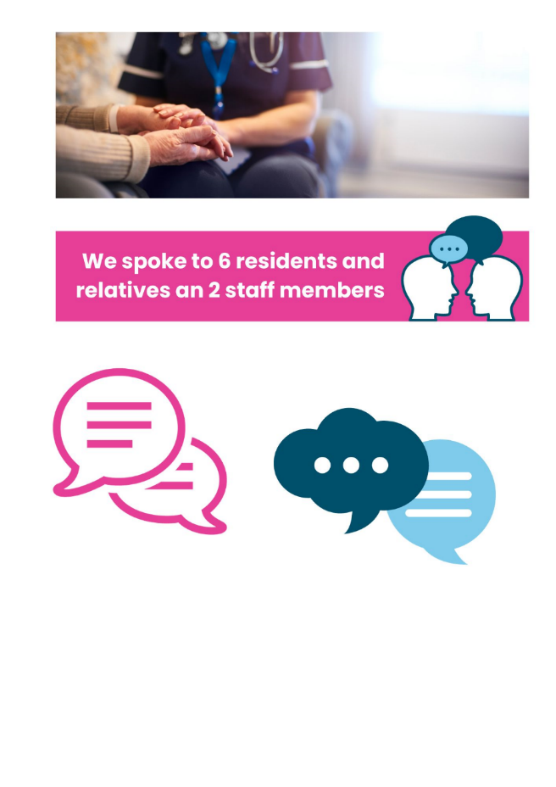
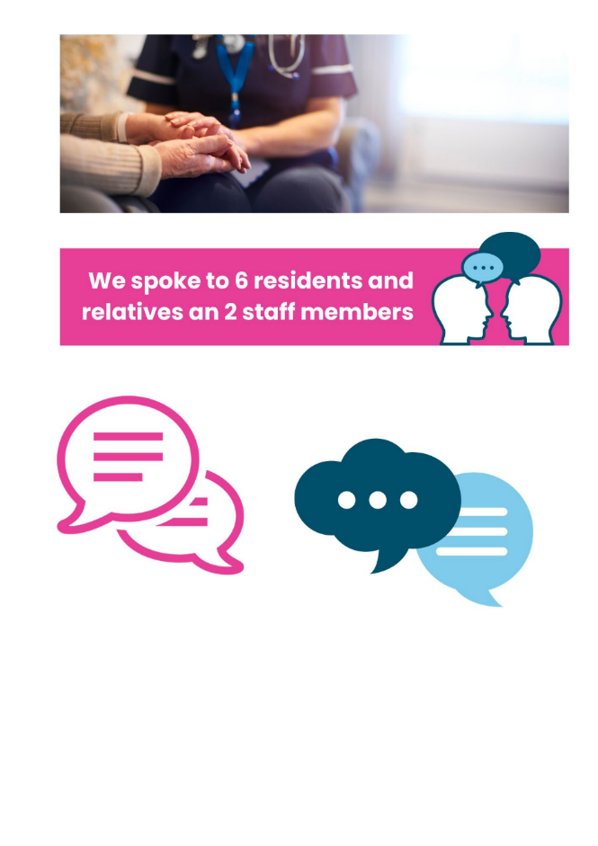
“Very nice, staff are very nice”
“Enjoyable, I enjoy each day, I enjoy living here”
“Boring, sometimes advised when to go to bed”
“Given choice”

We asked what choices they have?
“Make sure have choice on breakfast cereal or porridge, toast beans or tomatoes. Meets dietary needs”
“Yes, clothing food and bedtime”
” Yes but depends what’s available”
“Not much choice, staff are very kind. No activities”
“No choices. No activities., I enjoy my life”

We asked how safe they felt at the home?
“I feel very safe, no issues”
“Staff are very nice, feel very looked after”
“Yes, call system”
“Alarm bell, yes safe?”

We asked how long they had been in their home and if they are involved in their care?
Residents have been at the Home ranging from months to over six years
“A few months, my first choice of home”
“Days, new placement”
“A few months 2023”
“Over a year, can’t remember”

We asked if they felt cared for?
“Regular appointments, feel cared for”
“Regular appointments”
“Generally. Can see own GP if and when needed. Have eye appointment in near future.”
“Can see GP if needed. Someone comes and cuts hair”

We asked if they had an issue do they know who to speak to?
“Care staff, member in charge”
“Notify report to carer”
“Yes would speak to family and also staff”
“No Complaints”

We asked if they had an issue can they raise a concern without repercussions?
“Oh yes, capable”
“Yes, to many petty regulations, can’t visit bedroom in the day” *
“Yes, no problem”
“I think so”
*NOTE: We were told that the person is taken to their room but has mild dementia and does walk around so they keep an eye on them.

We asked if they have a balanced healthy diet, with drinks and activities?
“Can ask for a drink if wanted”
“Yes, fish love food, look after you”
“Food is very good, we get to choose what we want”
“Never had to ask for a drink. Always have something”

We asked how involved in their home they are?
“Have visitors, can use garden but with company”
“My family is very involved”
“Don’t know”

We asked if they could change one thing what would it be and why?

“Like entertainment, man every two weeks for half an hour”
“It’s a good place”
“Don’t want to change anything”
“I would like to change a lot but I don’t know what”

Whilst speaking to 2 residents, situations affecting them arose. Those situations with their permission have been forwarded to external support agencies who are dealing with these residents. It was not related to the delivery of care delivered by Highgate Lodge.


Relative Interviews
We spoke to 1 relative whilst visiting the home.

We asked what life was like for the resident in the home?
“Relative is safe. 24-hour care. Good”

We asked how safe they felt their loved one is at the home?
“Very safe”

We asked how long they had been in the home and if they are involved in their care?
“12 months”

We asked if they felt cared for?
“Yes, cared for.

We asked if they had an issue do they know who to speak to?
“Manager”

We asked if they had an issue can they raise a concern without repercussions?
“We could raise any issues”

We asked their relative if the resident has a balanced healthy diet, with drinks and activities?
“Relative is offered lots of food daily but can refuse”

We asked how involved are they in the care of the resident?
“Visit every day”

We asked if they could change one thing what would it be and why?
“Costs have gone up”


Staff Interview
We spoke to 1 staff member (a carer).

We asked if they felt confident in their role. “Feel very confident”.

We asked what the care planning and risk assessment process was that they work to? We were told the Manager undertakes the initial care planning.

When asked how much time they had to spend with residents? The staff member said “Depends on day as there a lot going on, would like to spend more time.”

We asked about staff training. They said that training and any ‘extra training’ is provided if needed. Staff always support.

We asked how they dealt with resident concerns/issues? “Report to Manager, very approachable”.

When asked about the supervision and support the staff member said “Very happy, regular supervision”.

The staff member said I would feel very confident, no issues, happy with role”.

When asked if they could change one thing what would it be? “More time with the residents. When activity person employed will be better”.

Under additional comments, the staff member mentioned that they have meetings and regular updates. There are handover sessions at the start of every shift. They have flash meetings through shifts to deal with any concerns or to share what is working well.

Management Interview
We spoke to the Manager who had been at the Home, initially as a Care Assistant progressing to the position of Manager in August 2020.

We asked if they felt confident in their role. They answered “Yes” and told us about their work journey.

We asked them to describe the care planning and risk assessment process. We were told that an initial plan is generated and if necessary a telephone call or visit to the location to see and further assess the potential resident needs can be carried out.

One point raised by the Manager was that the initial referral care plans are complete/ correct so visiting and seeing for yourself is always useful.

The Manager told us that they engage with residents daily when they can. One resident came to see the Manager during our chat and the Manager helped the resident to one of the carers for the support they needed.

We asked what training and support do they receive? The Manager has just completed their NVQ 5 there is also online training that they undertake. Support is available from the owners when required.

We asked how they deal with resident comments/concerns? We were told resident meetings take place every three months, relatives have one to one meetings and general information can be shared via the Home’s Facebook page.

The Manager seemed confident in their role and felt able to raise any concerns.

When asked if they could change one thing what would it be? We were told reduced/improved waiting lists i.e. Speech And Language Therapy (SALT). Response for an Ambulance call to attend. Example was called at 9.00am and didn’t turn up until 3.00pm. Also, District Nurses are not always available when needed.

We also asked what current challenges the Home faces? There are a few vacancies to fill. In addition, timely and up to date information from discharge team regarding

Findings
- The internal décor/paint/wallpaper is currently being refreshed.
- Drinks were consistently offered to the residents during our visit.
- Some residents felt there was not a lot of choice.
- There were mixed views about activities available and residents feeling bored.
- Activities had reduced to some exercise sessions from an external source with some additional but not daily activity.
- There are current vacancies for an Activities Co-Ordinator and Deputy Manager.
- A staff member said they would like to spend more time with residents and the employment of an Activities Co-Ordinator would help.
- There were no odours during our visit.

The 2 resident situations have been sent to Adult Social Care/Integrated Care Services. Clarification is needed for residents and the Home Manger around the situations of those residents.

Recommendations
- Ensure that individuals can have person focused activities/interests not just group activities.
- Identify any opportunities for external visits/activities for any resident that wish to go out and not subject to DoLS (Deprivation of Liberty Safeguards).
- Reinstate resident relative notice/activities board and position a suggestion box for residents/relatives to use.
- Recruit dedicated Activities Co-Ordinator and deliver person focused activities.
- Ensure that there are choices for residents around their personal likes and or dislikes.
- Seek to allow more staff time with residents when possible.

Provider feedback
The below response was received and added.

“We acquired Highgate Lodge Care hope, approximately 18 months ago and since then we have embarked on a multi-pronged strategy of renovating the building , improving the staff numbers and qualification and introducing systems and policies that are instrumental in improving the resident experience”.

“We have in this short period of time, achieved CQC "Good" rating. There is however much work that is still required and we will keep pushing ahead with our development blueprint. Our end goal is to provide to the citizens of Walsall an exemplary residential home for the elderly”.

If you wish to comment about this report please contact us.
Offices: Blakenall Village Centre
79 Thames Road
Blakenall
Walsall
WS3 1LZ
Tel: 0800 470 1660
Email: info@healthwatchwalsall.co.uk



