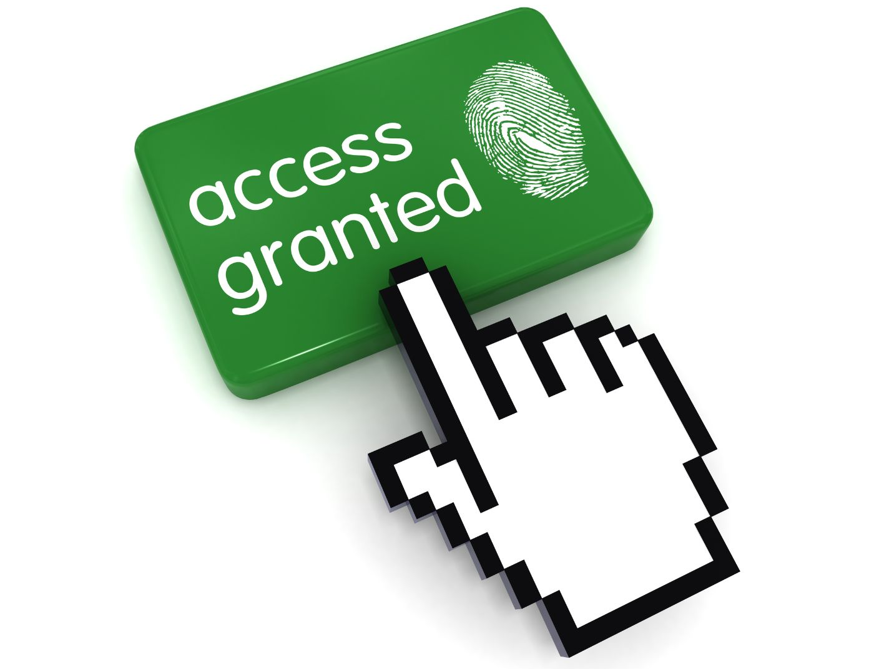

Accessible Information Standard
Report - March 2024


Managed by Engaging Communities Solutions

This report is written in a format that can also be accessed through ‘Read Aloud’ by using Microsoft Word.

Contents
Introduction Page 2-3
Who took part Page 3-4
What we did Page 4-5
Findings Page 5-11
Conclusions Page 12-13
Recommendations Page 13-14
Focus Groups Page 14-18
More information Page 19

INTRODUCTION
Healthwatch Walsall is the independent voice of the public in health and social care in Walsall. Healthwatch Walsall collects feedback from the public in Walsall about their experiences of using health and social care services and use that feedback to work with service providers and commissioners to find ways to improve services. One of the ways that we collect feedback is to carry out projects that reflect the priorities of the public and that focus on particular services, conditions or parts of the community.
On this occasion we carried out a project looking at the Accessible Information Standard to ensure it meets the needs of people with sensory impairment.
Guidance from NHS England states:
‘From 1 August 2016 onwards, all organisations that provide NHS care and/or publicly-funded adult social care are legally required to follow the Accessible Information Standard.’
‘The Standard sets out a specific, consistent approach to identifying, recording, flagging, sharing and meeting the information and communication support

needs of patients, service users, carers and parents with a disability, impairment or sensory loss.’
For more information around the standards in various formats please visit the NHS England Website, Link: http://tinyurl.com/44tbenru

We wanted a ‘local picture’ of how people with disabilities and/or sensory impairments are communicated with by Walsall health and social care services. We did this by listening to local people to find out if health and care services are
communicating with them in a way they can understand and to ensure it is meeting their needs. Are people in Walsall happy with the way they are being communicated with?

We found that whilst the majority of people with sensory loss or impairment were provided with information in a way that meets their needs this was not the case for everyone.
For people with sensory loss or impairment who are not being communicated with in the format required, there is an impact on them being able to access services and their health.
This report will be shared with health and social care service providers and the Walsall public.

WHO TOOK PART
We engaged with various people and communities such as the Blind or visually impaired, Deaf or hearing impaired and Learning Disabilities communities to gain their experiences and views of how services communicated with them.
Please note our questions are not mandatory giving participants the freedom to answer or not as they choose. Therefore there will be a discrepancy in the numbers shown in the demographic breakdown and questions answered.

Age range

16 to 17 years - 1
18 to 24 years – 12
25 to 49 years – 25
50 to 64 years - 13
65 to 79 years - 6
80+ years – 1

Gender

Female - 28
Male - 26
Non-binary - 3
I prefer to use my own word - 1

Understanding of English
I can speak, understand and read English well - 34
I can speak, understand and read some English - 15
I can’t speak, understand or read English at all - 4
I don’t know - 2
I prefer not to say - 2

Ethnicity
White: British English, Northern Irish, Scottish, Welsh - 24
White: Irish - 4
White: Gypsy, Traveller or Irish Traveller - 2
White: Any other White background - 3
Arab - 2
Asian British: Bangladeshi - 6
Asian British: Indian - 5
Asian British: Pakistani - 1
Asian British: Any other Asian British background - 2
Black British: African - 3
Black British: Caribbean - 2
Black British: Any other Black British background - 2

Health Conditions

Sight loss – 15
Hearing loss – 13
Learning Disability - 10
Mental health condition – 7
Another condition affecting communication – 4

WHAT WE DID
We used an existing survey that had previously been used by Healthwatch England. We contacted various groups and communities in Walsall to get a representation of their experiences and their views.
We then replicated the survey questions online and hard copy surveys were available in text and Easy Read formats so that we could engage with all.

Service users that could not directly participate, were supported by their carers or Healthwatch Walsall staff.
Link to Healthwatch England survey and findings used: http://tinyurl.com/5ynhx77c
In addition, we held 3 focus group discussions with people with sensory impairments and learning disabilities, who are most impacted and who should be supported by the Accessible Information Standard.


FINDINGS
There were a total of 61 responses to the survey and therefore, the findings have been presented as number of respondents rather than as percentages. Not all participants answered all the questions therefore there may be a disparity in the numbers presented.

Question 1 - Can you understand the information you are given by health and care services?

- 20 people could understand all the information that they were given.
- 20 people could understand some of the information they were given.
- 8 people found it difficult to understand most of the information they were given.
- 7 people did not understand any of the information they were given.

Question 2 - When using health or care services, have you ever asked for support to help understand any information you have been given?

- 36 people had asked for support.
- 17 people had not asked for support.
- 3 did not know.
- 2 preferred not to say.

Question 3 - When using health or care services, have you ever asked for support to help you contact health or care services?

- 33 people had asked for support in contacting health or care services.
- 17 people had not asked for any support.

Question 4 - When using health or care services, have you ever asked for support to help you communicate with staff?

- 30 people had asked for support to help them communicate with staff
- 14 people had not asked for support.
Question 5 – How do you find getting support from health and care services to understand information, contact them and communicate with staff. ?

- 25 people do not need any support and have never asked for any in relation to understanding information, contacting health and care services or communicating with staff.
- 13 people always get the help that they need.
- 11 people sometimes get the help that they need.
- 4 people don’t really get the support that they need.
- 2 people did not know that they could get support and so had never asked.

Question 6 - Has a health or care service ever refused to give you information in a way you can understand, even though you asked for it?
- 27 people advised us health or care service had refused to give them information in a way that they could understand, even though they had asked for it.
- 21 people had not experienced being refused information in a way that they could understand when they had asked.

Question 7 - What happened because of not being given information in a way that you could understand?

- 21 people could not contact the service that they needed.
- 20 people had missed their appointment.
- 11 people had affected mental health and wellbeing.
- 9 people could not understand how to take their medication.
- 4 people took the wrong dose of medication.
- 6 people received the wrong medication.
- 6 people missed important information about their health.
- 3 people could not understand and communicate with staff.
- 3 people had not known what they needed to do to keep themselves safe from Covid-19.
- 4 people had no impact on them at all.

Question 8 - Have you found it difficult to use any of these services because of communication problems?
- 32 people found it difficult to use GP services because of communication problems
- 19 people found it difficult to use dental services.
- 9 people found it difficult to use A&E
- 9 people found it difficult to use NHS 111.
- 5 people found it difficult to use mental health services
- 5 people found it difficult to use hospital appointment
- 2 people found hospital treatment difficult.
- 1 person had difficulty with Covid-19 vaccinations.
- 5 people found it difficult communication with social care

Question 9 - How do you feel about asking health or care services to provide information in a way that you can easily understand?

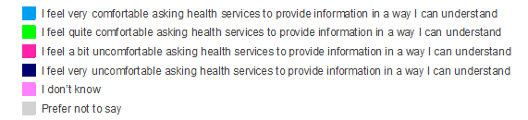

- 40 people felt very comfortable asking.
- 12 people felt quite comfortable.
- 2 people were a bit uncomfortable asking for information to be provided in a way that they understand.
- 1 person felt very uncomfortable asking.

Question 10 - What stops you from asking services to provide information or communicate with you in a way that you can easily understand?
- 35 people - attitude of the staff was a reason why they did not ask.
- 19 people - dependent on how confident they felt asking.
- 10 people - depended on whether they thought information would be available.
- 8 people - their ability to communicate with staff stopped them from asking for information in a way that they understand.

- 5 people - had a previous bad experience.
- 4 people - had support from friends and family.

Question 11 - If you are not given support with communication or information or if you are not communicated with in a way you can understand, do you know how to complain about it?

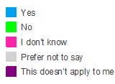
- 38 people knew how to complain if they were not provided with information they were able to understand or support to communicate with services.
- 9 people did not know how to complain.

Question 12 - Has anything changed about the way health and care services communicate with you since Covid-19 started?
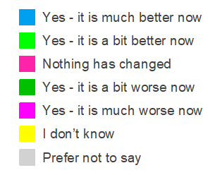
- 29 people - much better now.
- 9 people - a bit better.
- 7 people - nothing had changed.
- 4 people - a bit worse now.
- 6 people - much worse now.


CONCLUSIONS
The majority of people taking part in the survey either understood all the information they received from health and care services or understood some of it. However, there were some people who said that they either had difficulty understanding the information or understood none of the information they received.
Most people answering the questions said that they had asked for support with understanding information, contacting services or communicating with staff.
Although a higher number of people had received support when they asked than had not, the numbers being refused support were still relatively high suggesting that there are instances where people are left not being able to understand the information that they have been given despite requesting help.
When people had not received support when they had asked for it, the impacts varied with the most common being that service users were unable to contact services or missing appointments.
Most people said that they were comfortable asking for support. When asked what prevented them from asking for support, the highest number of people said that staff attitudes were a barrier to them asking for help, but so was their own confidence in asking and whether they believed that the information would be available in a way that they could understand.
GP services and dentists were the services that people found most difficult to use because of communication problems.
Most people said that they knew how to complain if they wanted to make a complaint about not receiving support when they had asked for it.
When asked if communication had improved since Covid-19, the highest number of people said that it had improved, although those who said it was worse were more likely to say it was a lot worse. The formats and availability of information services use to communicate with people with sensory impairments and disabilities can be inconsistent.
Consideration needs to be made that some people are not able to read or write, so person to person contact, whether this be verbally or face to face needs to remain an important communication method.
Access to interpreters is also an issue. The deaf community found it particularly difficult to have access to a British Sign Language interpreter, sometime taking

weeks. This may lead to the use of a family member to attend patient appointments.
Some current technology does not help communicate with people with specific conditions. i.e., Electronic ‘booking in’ touch screens are not suitable for Blind people. This, combined with the lack of any audio or verbal contact with a staff member may leave Blind/visually impaired patients remaining in the waiting room.
The lack of good and understandable communication from services can have both physical and mental health impacts on service users. Initial symptoms and causes may escalate from simple treatable levels to complex conditions that may need major intervention or may remain untreated. This may also increase any mental health issues especially around anxiety and worry as well trust issues with services in the future.
Good practice was highlighted by some services, NHS 111, Paramedics especially around the times of Covid, although it was noted that some support has stopped.

RECOMMENDATIONS
- Service providers should assess if they are currently communicating effectively with their service users to meet their needs.

- Providers should have suitable formats and technology to communicate with all service users in a way that is required and that these are working and readily available.

- Staff undertake awareness training around sensory impairments, effects and methods of communication that are available to bridge any communication difficulties.

- Service providers consider the delivery of customer service training. We would recommend that Dentists and GP services particularly consider this as these are the services that have been identified by patients/service users as posing most difficulty.

- The need for verbal or face-to-face communication is important for service users. Therefore, providers should be able to readily access interpreters.

- Look at where good practice takes place and replicate this.

- Where there are communication issues or lack of available interpreters, providers should reduce the waiting times for those patients needing these services.

FOCUS GROUPS
We held 3 focus groups with people from the Blind or visually impaired, Deaf or hearing impaired and Learning Disabilities communities in Walsall. Below are the discussion questions and summary of people’s answers.

BLIND AND OR VISUALLY IMPAIRED GROUP

How do health and or care service contact you in ways that you can access health or care information, i.e. a text message (what methods are used?)
- Email
- Text messaging
- Phone calls
- Braille
‘But not consistent’
Do services ensure that they use the communication methods that you can access and understand information such as: audio, braille, easy read or large print? (do they try? Which ones do? Which ones don’t?)

‘Some do, some don’t’
‘GP records not checked’
Are you offered support at appointments if you need them? Such as a Sign Language Interpreter being provided…or do you ask? What happens then?

‘No support, have to use a chaperone’

Do services offer facilities such as hearing loops if you use a hearing aid or visual aids if you are visually impaired, to support communicating with you?

‘Generally, no’

What affects does poor communication have with health & care services have on your life?

‘Don’t get treatment I may need’
‘Conditions get worse’
‘End up going to hospital in some cases’
‘Lack of appointments/GP access
‘Paramedics give advice and overridden by GP’
‘GP and Pharmacy issues, patients usually in the middle and asked to sort’
Main negatives

‘Electronic patient check in system no good to a blind person’
‘No audio at GP, have to rely on names being called out’

‘Patient transport can be an issue and getting to other hospitals if sent there’

What measures or changes could be made put in place to improve your communication experiences with health & care services?

‘Improve communication between professionals about my needs’
‘Improve staff communication to meet patient styles and needs’

LEARNING DISABILITIES GROUP
How do health and or care service contact you in ways that you can access health or care information, i.e. a text message (what methods are used?)

‘Telephone’
‘Text reminders’
‘Letters’
Do services ensure that they use the communication methods that you can access and understand information such as: audio, braille, easy read or large print? (do they try? Which ones do? Which ones don’t?)

‘No Nothing’

Are you offered support at appointments if you need them? Such as a Sign Language Interpreter being provided…or do you ask? What happens then?
‘Only if pre-arranged but get assistance from Mencap workers or relatives’
‘Lot of reliance on family and support staff’

Do services offer facilities such as hearing loops if you use a hearing aid or visual aids if you are visually impaired, to support communicating with you? (types of equipment available?)

‘Sometimes’

What effects does poor communication/accessibility with health & care services have on your life?

‘Can cause anxiety and worry to various levels’
‘Seems get told one thing by one person and then something else by another person’
‘Can be confusing and cause anxiety. Like they don’t talk to each other’
‘May not attend appointments if get anxious’

What measures/changes could be made/put in place to improve your communication experiences with health and care services?

‘Professionals could be more patient’
‘It seems that professionals don’t communicate with each other about the patient. So, get them communicating with each other better’
‘Staff read your notes before seeing you’
‘Explain things clearly to patient’
‘Don’t use jargon’
‘Identify staff. Hospital – not clear who or what people are i.e. Doctor, Nurse, Sister, etc’
‘Reduce waiting times. Long waiting times to be seen, sitting and waiting can cause anxiety’
‘Make it clear what support is available to people with learning disabilities’

We were also told by a support worker that their elderly person was taken to Accident & Emergency (A&E) and had their hearing aids removed, they could
not hear, and no family member was allowed to go with the patient into A&E bay.

Another person observed a 4 hour wait at hospital, which is difficult for someone with Autism.

DEAF AND OR HEARING-IMPAIRED GROUPROUP
This meeting was held in a looser framework from the previous focus groups.
There was a lot of discussion around the lack of people being able to access their GP, especially if they cannot read or write, which appears some people who are deaf can’t. Issues told to us are shown below.
Discussions also took place around having to book two weeks in advance to see a GP for an interpreter to be present for their appointment. ‘No-one plans to be ill’.
Having to go to their GP to book an interpreter for a hospital appointment. This has been happening for the past six months.
Some hospitals have remote interpreters Walsall Manor does not and it would be helpful if this was in place.
A person, who was in the group, brought a letter for a diabetic eyes screening appointment. They were unable to read, speak or hear to arrange this appointment and all their family members are deaf so no-one could do it for them. We asked the interpreter if they could do this for the person. They agreed to do it.
The support for people from social services is no longer in place I was informed that used to be available for these issues.
The Walsall Manor Hospital has an interpreter by text. We were informed by one person who is able to read, that they have never had a reply when they have tried to use this.
Much better support during lockdown, but a lot stopped after lockdown.
Some Apps on the are phone, ok if you can read, or have a smartphone or computer.

999 App works, Immediate interpreter comes on the phone screen, they are given a reference number after discussing their emergency needs. When paramedics arrive, they take the reference number and contact an online interpreter who is then available.
There appear to be lot of issues within this community around access to interpreters when they need them.

We were told that changes they would all like, are…

- Not having to book two weeks in advance for a GP appointment etc.
- We used to have cards for trying to book interpreters, this has been stopped
- A lot of good tools around NHS 111 take a look and other services consider same styles/types
“SIMPLE, we need all professionals and frontline staff who we are involved with, to be able to book an interpreter”

MORE INFORMATION AROUND ACCESSIBLE INFORMATION STANDARDS
Link to Healthwatch England findings and report link: http://tinyurl.com/35k35efj

Easy Read version link: http://tinyurl.com/hyhkps3d

NHS England - What you can expect from services link to video: http://tinyurl.com/mrxsk28j

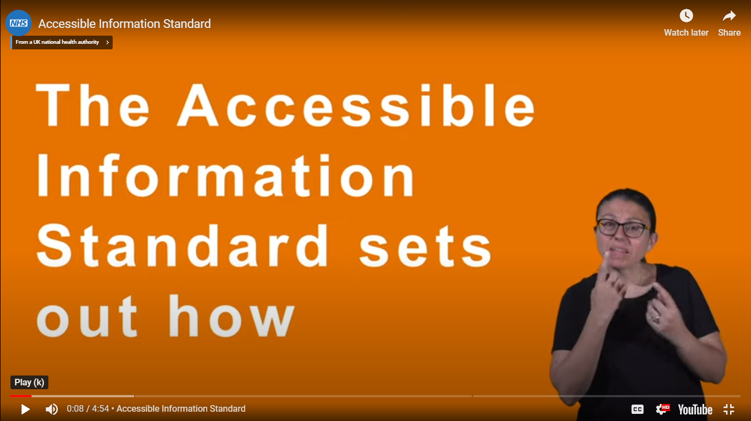

NHS England outline.
Link: https://tinyurl.com/44tbenru

Share you experiences and or views of Accessible Information Standard when accessing health or social care services in Walsall.

Managed by Engaging Communities Solutions
HOW TO CONTACT US
Telephone: 0800 470 1660
Email: info@healthwatchwalsall.co.uk

Blakenall Village Centre
79 Thames Road
Blakenall
Walsall
WS3 1LZ

